Query 1 - Database name
company_db
Query 2 - Customer Table Query
CREATE TABLE customer
(
customer_id INT PRIMARY KEY,
cust_name VARCHAR(50),
city VARCHAR(50),
grade INT,
salesman_id INT
);
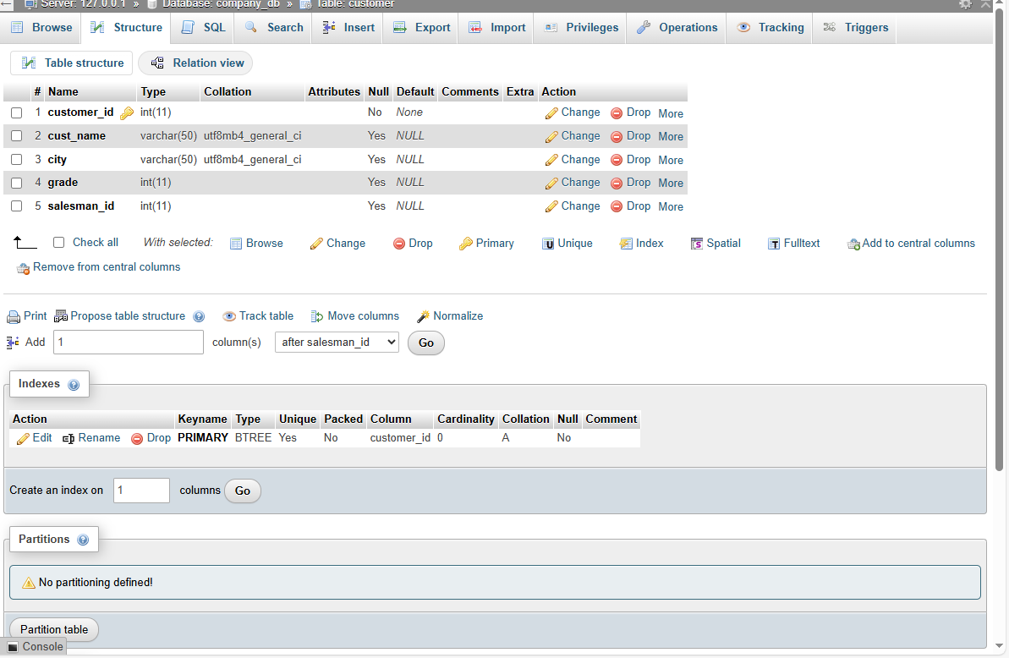

Query 3 - Customer Table Data Insert Query
INSERT INTO customer VALUES
(3002,'Nick Rimando','New York',100,5001),
(3007,'Brad Davis','New York',200,5001),
(3005,'Graham Zusi','California',200,5002),
(3008,'Julian Green','London',300,5002),
(3004,'Fabian Johnson','Paris',300,5006),
(3009,'Geoff Cameron','Berlin',100,5003),
(3003,'Jozy Altidor','Moscow',200,5007),
(3001,'Brad Guzan','London',NULL,5005);
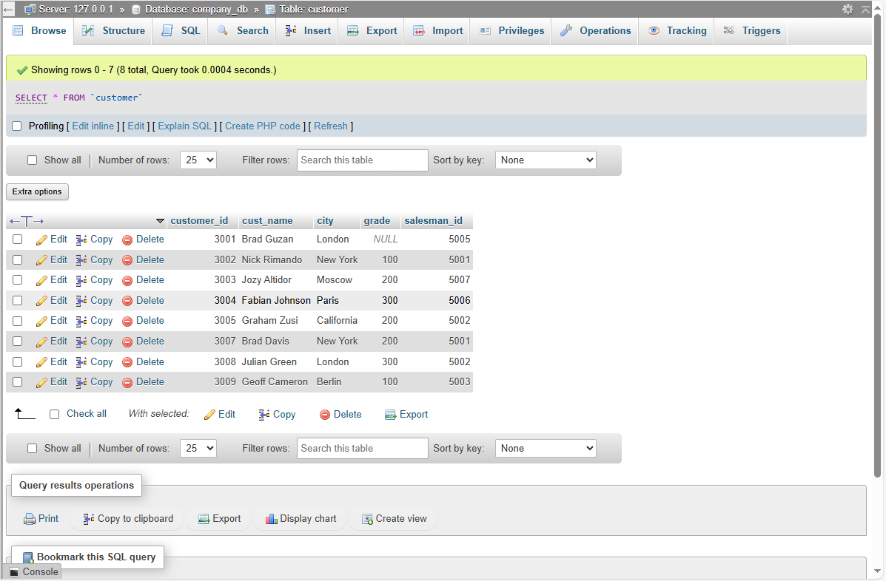

Query 4 - Salesman Table Query
CREATE TABLE salesman (
salesman_id INT PRIMARY KEY,
name VARCHAR(50),
city VARCHAR(50),
commission DECIMAL(4,2)
);
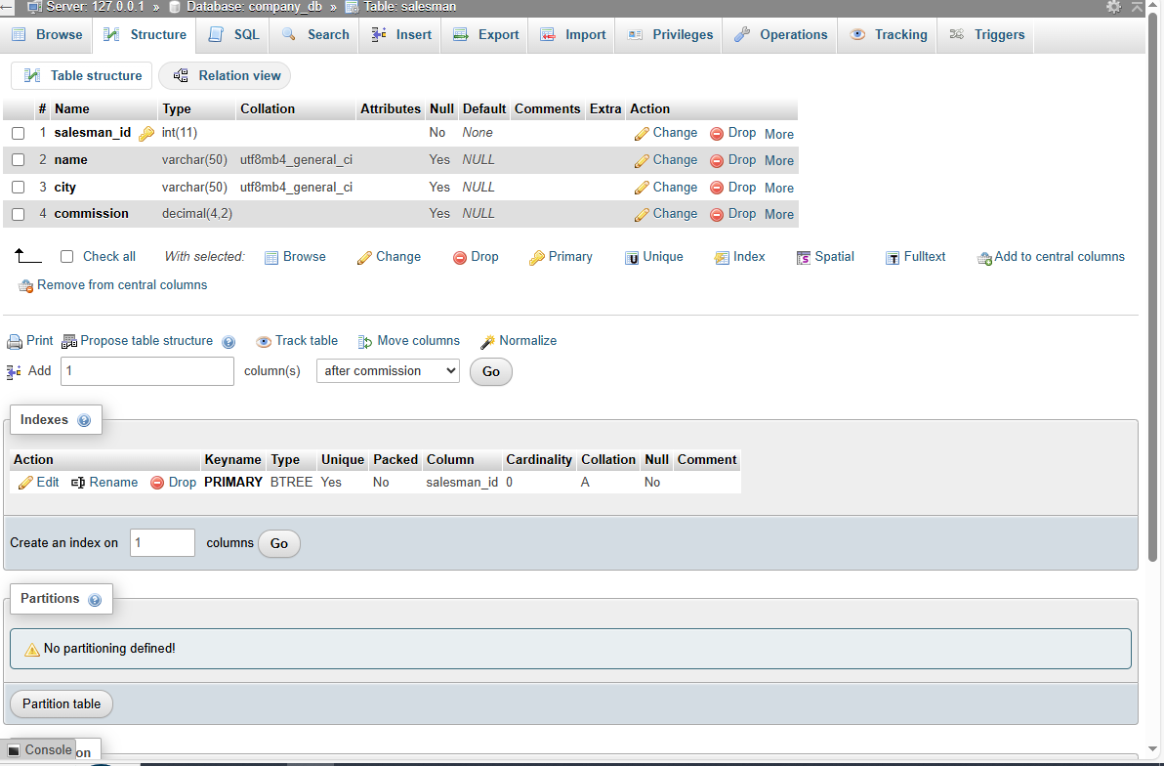

Query 5 - Salesman Table Data Insert Query
INSERT INTO salesman VALUES
(5001,'James Hoog','New York',0.15),
(5002,'Nail Knite','Paris',0.13),
(5005,'Pit Alex','London',0.11),
(5006,'Mc Lyon','Paris',0.14),
(5007,'Paul Adam','Rome',0.13),
(5003,'Lauson Hen','San Jose',0.12);
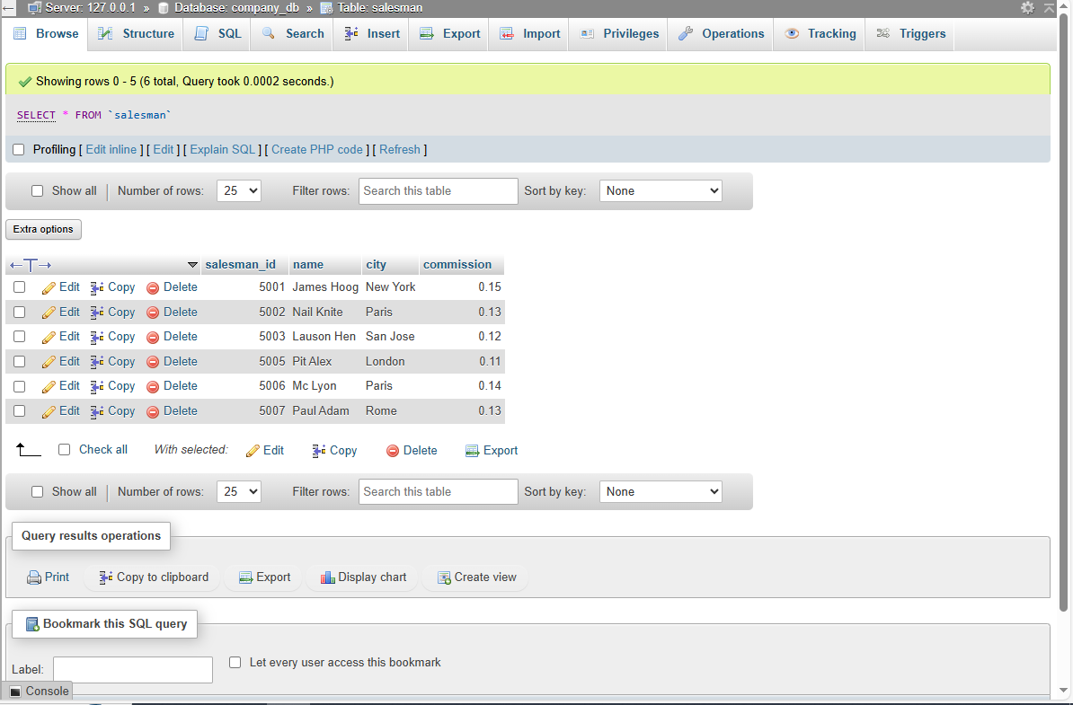

Query 6 - Required JOIN Query
SELECT
customer.cust_name AS Customer_Name,
customer.city AS Customer_City,
salesman.name AS Salesman_Name,
salesman.commission
FROM customer
INNER JOIN salesman
ON customer.salesman_id = salesman.salesman_id;
